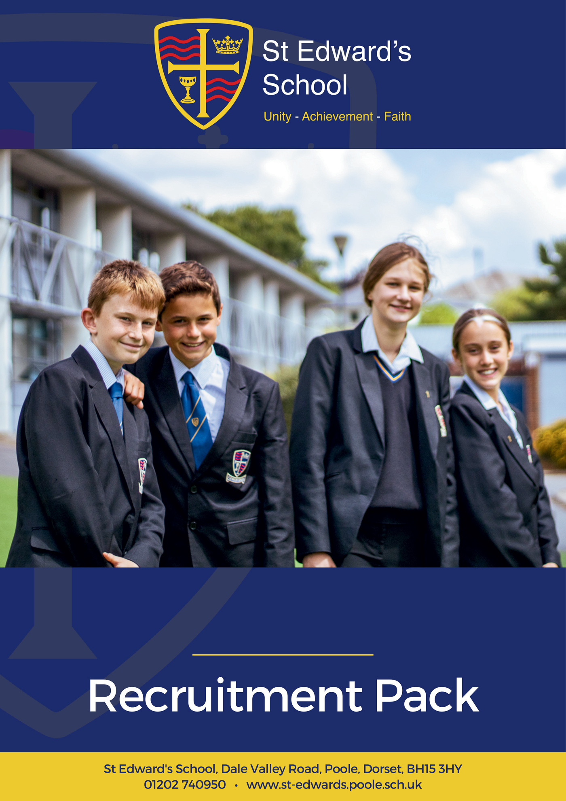

FINANCE ADMINISTRATOR

FINANCE ADMINISTRATOR
Grade E SCP 7 – 11 depending on experience.
£24,294 - £25,979 Pro Rata
Actual Salary £21,338 - £22,818

St Edward’s School is a high-performing school, supported by an excellent administrative team. Our school is heavily oversubscribed and enjoys an excellent reputation for combining high expectations of all, with warm relational approaches to learning.
We are looking for an experienced, adaptable, and enthusiastic Finance Administrator with excellent interpersonal skills to join our friendly, busy support staff team.
What are we looking for in you? Applicants will need to be experienced, enthusiastic, proactive, and familiar with the secondary school context. You will have a sincere commitment to our ethos and vision as a school, and our drive for continuous improvement. In return we offer a happy working environment, fantastic students, great facilities, tailored CPD and a highly motivated staff community.
The post is permanent 37 hours per week Monday to Friday 8.30am – 4.30pm. Term time including inset days and one week in the school holiday period.
Please visit our website at https://st-edwards.poole.sch.uk/ for further information about our unique school.
St Edward’s School is committed to safeguarding & promoting the welfare of children & young people. All appointments made are subject to an enhanced DBS check. Online searches may be carried out as part of due diligence checks.

Closing Date: Sunday 14 April 2024
Interviews: TBC

Our Mission Statement
MAY WE BE ONE
In Purpose
Educating for life in all its fullness
In Faith
Encountering God who lives among us, calling us to unity
In Dignity
Nurturing confidence and maturity
About Us
St Edward’s School opened in 1963 as Roman Catholic School serving the parishes of Poole. It took its name from the local Saint, martyred at Corfe Castle. Although little is known of Edward, as a teenage king with a strong Christian faith and a commitment to protecting the poor he provides an excellent role model for our young people. His story is told through our school badge with the crown of a king, the cross of Christ, a cup to symbolise his murder by poisoning and the blood of a martyr. The crown and cup also remind us of the Kingdom of God, and the “one cup in which we all share”. (1Cov 10:16)
For many years, the school welcomed not only Roman Catholic families, but other Christians who were keen for their children to be educated in a faith context. In the early 1990’s the school’s second headteacher, Alan Murphy decided to formalise this arrangement and entered into talks with the Roman Catholic Church and the Church of England about St Edward’s becoming a joint church school. A new covenant, setting out the values and principles behind the commitment was signed by the Bishops of Plymouth and Salisbury in 1993.
From then on, the school has continued to grow in success and popularity. The vision of the school is to provide an excellent education, in a comprehensive and co-educational context that develops the character of young people through the St Edward’s Virtues, while safeguarding their experience of childhood.

Letter from the Executive Headteacher
At St Edward’s School we are committed to preparing young people to live life to the full.
We have the highest expectations of all of our students, and they leave us ready to go to some of the best universities in the world, to exciting employment opportunities, or empowered to take their next steps in learning. We believe that preparation for life is best facilitated in the midst of a caring and supportive community but one that does not allow excuses for poor behaviour. A community that attends to spiritual and moral formation, as well as academic excellence.
Our school is a very successful, heavily oversubscribed, and distinctive joint Roman Catholic – Church of England Voluntary Aided School supported by the Roman Catholic Diocese of Plymouth and the Church of England Diocese of Salisbury. We are a truly comprehensive school, which educates over 1000 students from the age of 11 to 18.
We want every student to experience gospel values on a day-to-day basis throughout the curriculum and also to promote a happy learning community supported by a strong Christian ethos where everyone feels valued, and where opportunities for enrichment allow gifts and talents to be developed, for each and every student.
We believe that children deserve to be equipped for life with the best education, together with values that enable them to navigate future choices and opportunities. We are committed to providing both. We collaborate with parents and carers in bringing up their children, and work with local church communities in guiding young people as they seek answers to questions of meaning and purpose. To this end we welcome representatives from a range of church communities to exercise their ministry among us.
I believe that St Edward’s is a very special place to be, as confirmed by Ofsted, who in their most recent inspection in 2022 celebrated our positive learning community, with respectful, kind and polite students. Our curriculum was highlighted as being ambitious and challenging, strongly preparing students for future success. Our most recent Church School Inspection in 2023 rated us “outstanding” in all areas.
I am proud of our wonderful students, our dedicated staff and our supportive governors, parents and carers. I hope that your experience of us will lead you to believe that St Edward’s is the right home for you.

Mr Michael Antram
Executive Headteacher
Working at St Edward’s
St Edward’s is a popular place to work with low staff turnover and high levels of staff wellbeing and satisfaction. Our mission statement of ‘may we be one’ goes to the heart of what we do and how we do it and staff feel positive about the school and their role within it.
We have invested in the Employee Assistance Programme, which gives all staff access to confidential advice and support. The 24-hour support covers a wide range of areas, both work related and more general, including counselling, specialist information and financial and legal matters.
“EAP will always be there to support teachers and education staff no matter what you’re going through, big or small, we’re here for you. Day or night you can call to speak to someone without judgement who can help you find solutions to move past a difficult situation in your life.”
I am normally able to manage my wellbeing | If work gets difficult, I know how to get support | I enjoy my work
92% | 97% | 99%
Staff Wellbeing Survey – Autumn 2023

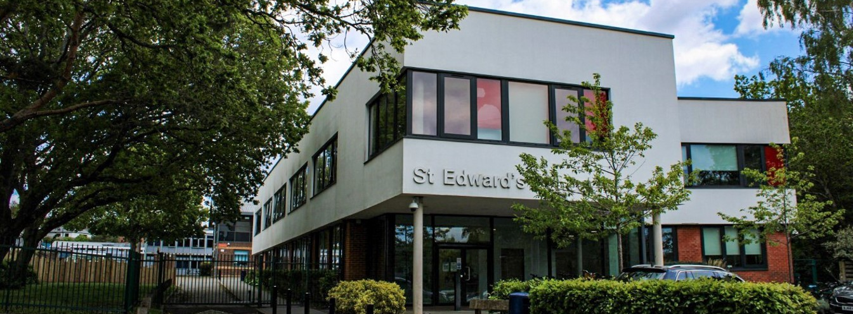
Staff Testimonials
“As a new member of the support staff I immediately felt welcomed by the team and the wider staff. Everyone has been very friendly and approachable allowing me to quickly feel settled and supported in my role.”

Lucy Lumber, Library Administrator
1 year at St Edward’s
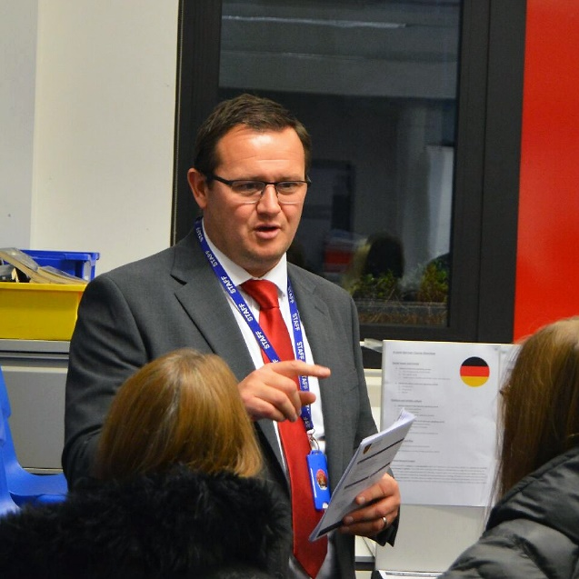 | “There are many reasons I have been at St Edward’s for more than 15 years, but probably the main one is the people here. Everyone is pulling in the same direction; the brilliant, polite, and friendly students, our happy and dedicated staff, and the supportive and capable leadership team.”  Matthew Lenarduzzi, Head of MFL  15 years at St Edward’s
“When staff leave St Edward’s, they always say something along the lines of… “This school is not like other schools. The staff care and look after each other. They are a community and there’s something special about working here.” I’ve always felt this and known this. Coming to work each day in a place where people genuinely care about you makes me feel very fortunate to work here. St Edward’s has always prided itself on caring about the whole child and I’ve always felt proud to be a part of that vision.”  Suzanne Bland, Teacher of PE  22 years at St Edward’s | 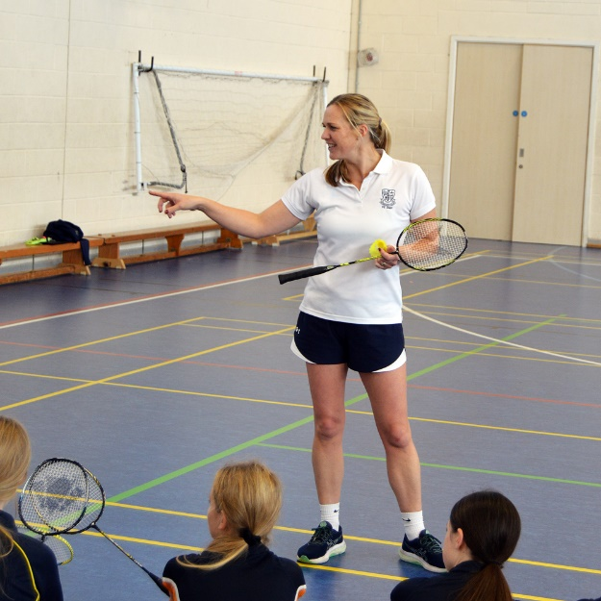
Staff Recruitment Information
APPLYING
Please read the Job Description and Person Specification before fully completing the application form. Where there are any gaps in your employment, please state the reasons why e.g. gap year, career break, unemployed etc. and give exact dates.

SUPPORTING INFORMATION
This section is very important as it gives you the opportunity to show us why you are applying and why you would be the best person for the job advertised. Please use the job description and person specification as a guide and give specific examples where possible, to demonstrate how you match the requirements of the post.

INTERVIEW AND SELECTION PROCESS
Those candidates who meet the requirements for the post will be shortlisted and invited to interview and details of the interview programme will be confirmed in writing. As part of the selection process, as well as assessing your skills and knowledge against the requirements of the role, specific questions will be asked to assess your suitability to work with children.

Under the Disability Discrimination Act 1995 and 2005, we are legally required to consider making reasonable adjustments to ensure that disabled people are not disadvantaged in the recruitment and selection process. We are therefore committed to meeting, wherever possible, any needs you specify on the application form. Please contact us if you need to discuss this in any detail.

We will consider any reasonable adjustments under the terms of the Disability Discrimination Act to enable an applicant with a disability (as defined under the act) to meet the requirements of the post.

Safeguarding
St Edward’s is committed to safeguarding and promoting the welfare of children and young people and expects all staff and volunteers to share this commitment.

If you do not hear from us by the interview date specified in the advert, please assume that you have not been shortlisted on this occasion.

PRE-EMPLOYMENT CHECKS

References
If you are shortlisted, we will normally take up references before the interview date. One of your referees must be your current or most recent employer. All offers of a post are made subject to receipt of satisfactory references without which we cannot confirm any offer of an appointment. Copies of references or references that are addressed “to whom it may concern” will not be accepted. On receipt of references, your referees may be contacted to verify any discrepancies, anomalies or relevant issues as part of the recruitment verification process.

Disclosure & Barring Service Check (DBS)
Employment is subject to an enhanced DBS check. Checks will also be made against the Protection of Children List (PoCAL) and the Department of Education and Employment List 99. All such checks must be satisfactory before we confirm any offer of an appointment. Teachers are also checked against the Prohibition from Teaching check.

Under the Rehabilitation of Offenders Act 1974 (Exemption Amendment) Order 1986, there are a number of jobs where we must take account of convictions, even though they are ‘spent’. All posts at St Edward’s School are regarded as such. However, spent and/or unspent convictions may not necessarily make you unsuitable for appointment.

The amendments to the Exceptions Order 1975 (2013 & 2020) provide that certain spent convictions and cautions are ‘protected ‘and are not subject to disclosure to employers and cannot be taken into account.

Validation of Qualifications
All short listed candidates will be asked to bring original certificates of relevant qualifications to interview. These will be photocopied and kept on file and may be confirmed as genuine with the relevant awarding bodies.

Right to Work in the United Kingdom
Under the Asylum and Immigration Act 1996, it is a criminal offence to employ anyone who is not entitled to live or work in the United Kingdom. Proof of this will be required at interview stage, where you will be asked to provide some original documentation to confirm that you are eligible to work within the UK. Photographic proof of identity will also be required.

Medical Assessment
A satisfactory medical assessment will be required before we confirm any offer of an appointment.

Child Protection
We are committed to safeguarding and promoting the welfare of children and young people and expect all staff and volunteers to share this commitment. We have a designated senior member of the leadership who is responsible for referring and monitoring any suspected cases of abuse. All members of staff will receive training in line with our child protection policy.

Code of Conduct
We believe that it is essential for standard of conduct at work to be maintained to ensure delivery of quality services and also to protect the wellbeing of all its employees and students.

St Edward’s School governors and headteacher regard everyone working within St Edward’s as a role mode to our students. As such employees should conduct themselves with integrity, impartiality, and honesty. Furthermore, everyone within St Edward’s school has an absolute duty to promote and safeguard the welfare of children.
JOB DESCRIPTION

Job Title: | Finance Administrator
Salary Grade: | E SCP 7 - 11  £24,294 - £25,979 PRO RATA  Actual Salary £21,338 - £22,818
Working Hours: | 37 hours per week Monday – Friday 8.30am to 4.30pm. 4.00pm finish one day per week.  Term time, including INSET days, plus 5 days in school holidays
Responsible to: | Finance Officer/Office Manager

Main Job Purpose
- Provide efficient and effective administrative support to the Finance Officer.
- To provide efficient administrative support to specific staff members when necessary.
- To ensure compliance with all relevant school policies and statutory reporting requirements, including undertaking data entry/analysis, recording on SIMS, the school MIS system.

Main Responsibilities and Duties
- Provide a comprehensive administrative support to the Finance Officer.

- Provide support and cover for the Data administrator.

- Use ICT systems (e.g. SIMS) and programmes to assist in the production of reports such as transfer data, term and annual attendance returns and other school data returns as required.

- Use ICT systems and programmes to assist in the production of reports, information sheets and administer the school’s financial management system including mismatches, journals, the building fund including an annual appeal and monitoring of monthly standing orders and reclaim Gift Aid Tax as required.

- To be responsible for the administration of the Duke of Edinburgh Award. Training will be provided.

- Advise and answer queries relating to budgetary matters from various stakeholders such as the Headteacher, Bursar, governors, departmental heads, BCP, and dioceses if applicable.
- Prepare financial reports for various stakeholders such as the Headteacher, Bursar, governors, departmental heads, BCP, and dioceses if applicable.

- Assist in the preparation of statutory returns to agencies such as the Department for Children, Schools and Families and BCP.

- Advise departmental heads and other delegated budget holders with ordering or budget queries.

- Receipt and dispersal of cash following school’s policies and procedures.

- Reconciliation of cash accounts and use of bank accounts

- Process incoming and outgoing invoices.

- General office duties such as photocopying, scanning and filing.

- Work in accordance with all school and Financial Management Standard in Schools policies and procedures.

- The post may include some collecting and handling cash. Examples are payments for exams.

- The post holder will be required to assist in the organisation and administration of school services such as arranging dates for visits by health professionals and application of free school meals.

- The post holder will be required to have an understanding and awareness of other functions of the admin support team, such as reception and the student office.

- To provide as required, and as appropriate, cover for the work of other members of the administration team.

- The post holder will be required to contact parents and act as a point of first contact for parents and carers and prospective parents and carers.

- Have a commitment to safeguarding and promoting the welfare of children and young people in accordance with the school’s agreed procedure.

- Undertake such other duties as may be required from time to time commensurate with the level of the post. The particular duties and responsibilities attached to the post may vary from time to time without changing the general character of the duties or the level of responsibility entailed.
- Comply with all decisions, policies, and standing orders of the school and BCP; comply with any relevant statutory requirements, including Equal Opportunities legislation, the Health and Safety at Work Act, GDPR and the Data Protection Act.

PERSON SPECIFICATION – FINANCE ADMINISTRATOR
 | CRITERIA | ESSENTIAL (E)  DESIRABLE (D) |  | METHOD OF  ASSESSMENT
 |  | E | D | Application – A  Interview – I  References - R
EXPERIENCE
 | Proven experience of working in a busy, pressurised finance role (minimum 1 year) |  |  | A, I, R
 | Experience pf providing direct support to internal and external customers, face to face and by telephone |  |  | A, I, R
 | Experience of working in an educational environment |  |  | A, I, R
EDUCATION AND PROFESSIONAL QUALIFICATIONS
 | English & Maths GCSE Grade C/Level 5 or above |  |  | A
 | Appropriate qualification in a financial role |  |  | A
 | ICT qualification in Word and Excel |  |  | A
APTITUDES AND ABILITIES
 | Ability to work on own initiative and as a member of a team |  |  | A, I, R
 | To be able to be well organised and manage ever competing priorities |  |  | A, I, R
 | Ability to use Finance packages and budget tools e.g. Financials Live, Budgeting software |  |  | A, I, R
 | Computer skills in main commonly used office packages such as Microsoft Office |  |  | A, I, R
 | Excellent communication skills - verbal and written |  |  | A, I, R
 | Attention to detail, organised and methodical |  |  | A, I, R
KNOWLEDGE
 | Understanding of GDPR and Data Protection and high level of confidentiality |  |  | A, I
 | Understanding of health and safety issues relating to the job description |  |  | A, I
 | Understanding of Administrative processes |  |  | A, I
ATTITUDE / MOTIVATION
 | Willingness to support the school’s mission statement |  |  | I
 | Enthusiastic and cheerful |  |  | I
 | Flexible and adaptable |  |  | I, R
 | Keen to achieve and develop skills |  |  | I, R
 | Excellent communication skills |  |  | I, R
Ofsted (2022) and Section 48 (2023) Quotes

Ofsted
“This school is a positive learning community.” | “The core values of kindness, hard work and the development of individual strengths and skills are evident in the school’s work.”
“There are positive and respectful relationships between staff and pupils. This leads to a calm learning environment.” | “Pupils are happy, friendly and polite.”
“This school is well led and managed.” | “The school’s ethos and values run through all they do: unity, achievement, faith.”
“Leaders ensure that there is an ambitious and challenging curriculum in place.” | “There is strong moral leadership from the headteacher.”
“Everything leaders do are in the best interests of the pupils that attend the school.” | “Staff have a very positive view of leaders. They say leaders are approachable and considerate of their workload.”
“Governors understand their responsibilities well and are cognisant of the need to support staff wellbeing.” | “Teachers have high expectations of what pupils can achieve through the curriculum.”
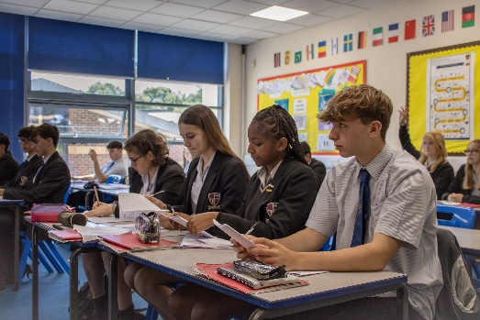

Section 48
“The mission statement is a clear and inspiring statement of the mission of the church and is lived out and understood by the whole community.” | “Provision for pastoral care is a strength of this school which takes supporting the development of the whole person seriously.”
“Leaders and governors have a clear and inspiring vision of the mission of the school.” | “The pastoral care of students is a priority for the school and as a result students feel valued and listened to.”
To Apply for the Position
If you are interested in applying for this role, we would love to hear from you. Please complete and return the application form on our website:
https://st-edwards.poole.sch.uk/information/recruitment/
Please do not submit additional documentation at this stage.
The deadline for receipt of applications is published on our website.
Interviews will be held shortly afterwards.
Thank you for your interest and for taking the time to apply to St Edward’s School.
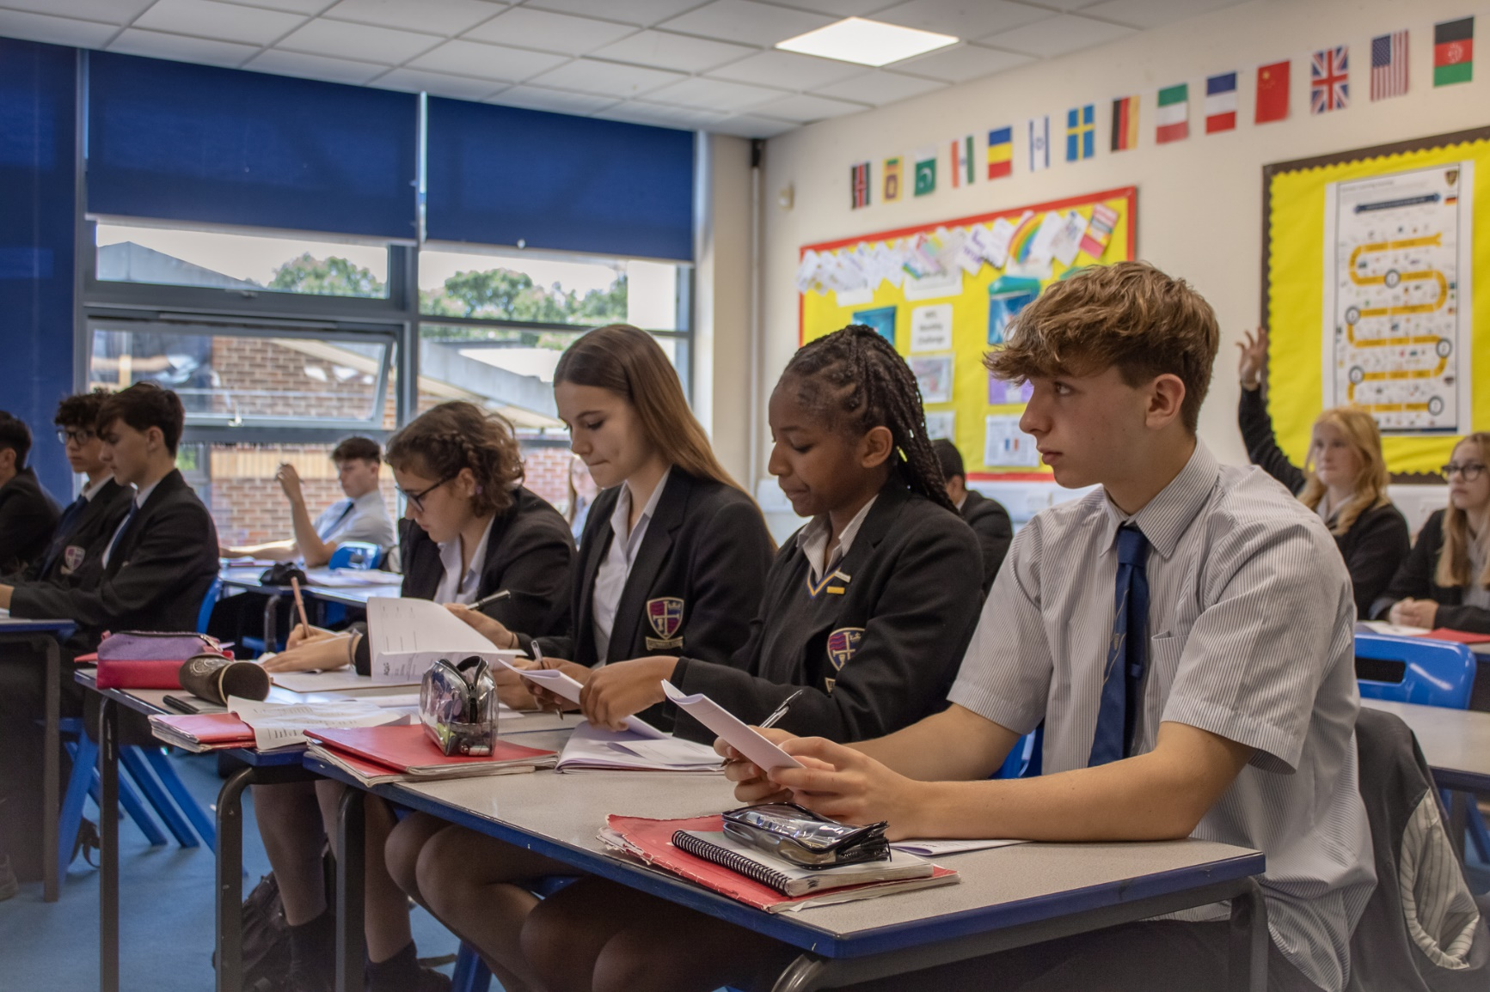
Parent of Year 11 child, 2023
“Huge thanks for all the efforts made by teachers, having excellent teachers that inspire and encourage in such a supportive way makes all the difference. Thank you!”
“My son loves his new school, he has settled very well because of friendly and helpful staff at school.”
Parent of Year 7 child, 2023

